Debrief of Tour: City of Lawton Activated Sludge Wastewater Treatment Plant
Date of Tour: 6/26/2024
Participants:
- Michael Hixson (External Affairs Manager AEP)
- Greg Carter (SWEPCO Engineer AEP)
- Kevin Ouellette (Energy Production Supervisor Comanche Generation Facility)
- Thomas Hancox (Plant Manager Comanche Generation Facility)
- Adam Oberst (Plant Environmental Coordinator, Comanche Generation Facility)
- Danny Engle (Environmental Services Intern)
- David Hastings (Supervisor Wastewater Treatment Facility, City of Lawton)
Purpose of Tour:
The tour was organized by Tim Hushbeck to address concerns regarding the quality and reliability of treated water being supplied to AEP Comanche Generation Facility from the CoL Wastewater Treatment plant. The focus was on understanding the treatment processes, ongoing and future upgrades, and any potential impacts on water quality that could affect the operation of the Comanche Generation Facility.
Tour Overview:
- Process Walk of Influent: Tour began with overview of Influent Process where raw sewage enters plant via 60” pipe where large debris like tires and bicycles for example are ingested
- Remove of Large Debris: Large debris is removed via screens and augers to prevent subsequent damage to equipment in treatment process. These are going to be upgraded in phase 1, and was described as “fix the head and the tail will follow” – David Hastings
- Grit Removal: Grit sized objects are removed via sand based filters to prevent abrasion of equipment- and accumulation in tanks. This is another upgrade in the phase 1
- Sludge Sedimentation and Bacterial Activation (Clarifiers): Sludge is allowed to settle and bacterial activation is initiated to break down organic matter
- Aeration: The aeration process introduces oxygen to support the biological treatment process promoting the growth of beneficial micro-organisms
- Sanitation: Treated water undergoes sanitation through chemical treatments (12.5% chlorine and sodium bisulfate to dechlorinate) and UV light radiation to eliminate pathogens
- Total Suspended Solids (TSS) Filters: TSS filters are used to remove fine particulate matter from treated water
- Bio-Aquatics for Biomonitoring: The plant utilizes biomonitoring to ensure treated water supports aquatic life but does not have on-site lab so must rely on contractors.
- Sampling and Testing: The facility has an on-site water lab for non-biological testing and is graded on 6 types of samples that are taken seasonally as applicable for conditions
Facility Upgrades and Future Plans:
- Phase 1 $85,000,000 upgrade: CoL is currently undergoing an upgrade that is scheduled to complete June 2025 and aims to enhance the plant efficiency and reliability
- Phase 2: Improve aerobic process and relocate part of the facility out of the flood zone to mitigate flood risks and enhance stability (Effluent pond is located in flood zone)
- Phase 3: Plans to construct new facility entirely out of flood zone ensuring long-term resilience and improved treatment capabilities
On-going Issues:
- Republic Paperboard: Industrial Polluters that is undergoing $20,000,000 upgrade to their treatment operation to release improved effluent to CoL
- Jobs: Republic directly employs 247 jobs and possibly PSO customer
- Politics: Republic is currently permitted to discharge water under CoL permit and not through EPA/ODEQ thus enforcement is on-going via CoL. The phrase “Political water is the hardest to treat” – David Hastings makes sense because despite the CoL being responsible to enforce their permit with Republic the level of action goes to the Mayor and involves stakeholders that make the issue more complicated than simple Notice of Violations
- Goodyear tires: Another large industrial employer using CoL sewage but no specific issues were brought up during tour as remarks about their contribution
- Age of Plant and geography: Plant was built in 1977 and is the only treatment plant of CoL. Additionally the plant is locations on flood plain and Lawton sees extreme droughts and floods. Equipment is very old and maintenance issues are on-going while plant can’t be taken offline for heavy maintenance because “People don’t stop flushing” – David Hastings
Specific concerns for AEP Comanche Generation Facility:
- AEP is concerns about organic pollutant levels and residual pathogens in treated water which could affect cooling system operations and plant efficiency and contribute to high Biological Oxygen Dement (BOD) that cause fish kills particularly in hot months during summer.
- AEP personnel are not specialized in hazards presented from water that need to be addressed with AEP equipment
- Violations could be directed at AEP due to pollutants that are not caused by AEP operations
Mitigation Measures and Recommendations:
- Treatment plant has recently upgraded monitoring equipment and implemented more stringent operational protocols to address water quality concerns
- Collaborative efforts to enhance water quality monitoring and data sharing between treatment plant and generation plant
- Explore treatment options or supplemental filtration systems at point of use to ensure highest quality for generation facility
Conclusion:
The tour provided valuable insights into treatment processes, challenges and significant ongoing and future upgrades at CoL wastewater treatment plant. While plant is generally effective in producing treated water that meets regulatory standards, there are legitimate concerns about occasional variability in water quality. Continued collaboration and enhanced monitoring efforts between AEP and treatment plant are essential to reliability and safety of water supplied to Comanche Generation Facility. The planned upgraded are steps toward addressing these concerns and improving water quality and reliability.
Next Steps:
- Schedule follow-up meetings to discuss collaboration opportunities
- Evaluate potential supplemental treatment options at Comanche Generation Facility
- Review and assess impact of recent upgraded and effluent water

Photos:
- Aeration
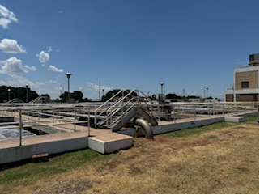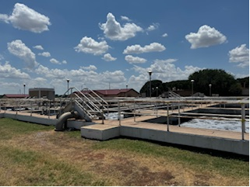
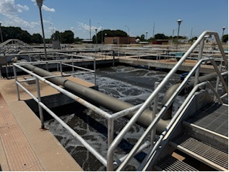

- Grit Removal
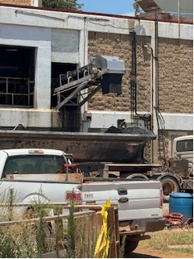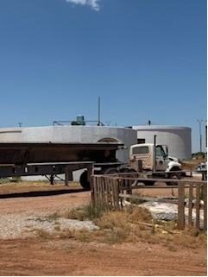

- Large Debris Removal
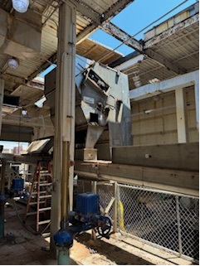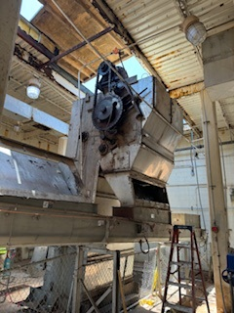
- Sedimentation/Clarifiers
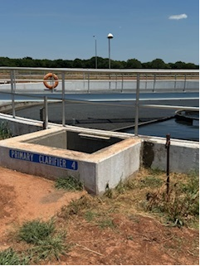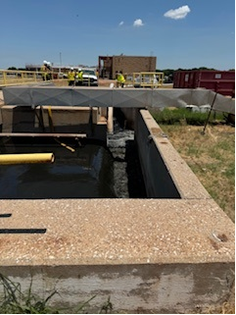
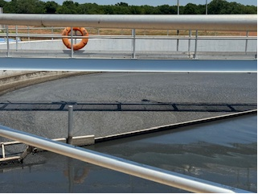
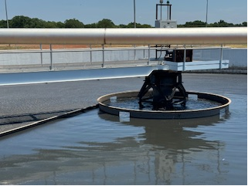
This is one of the later stage clarifier tanks and noticed the birds being attracted to the water to eat tomato seeds. I didn’t know these make it through the process and are not even digested by humans either.
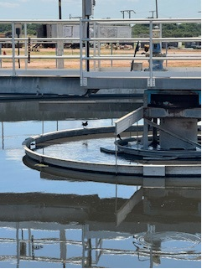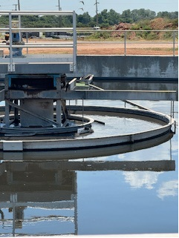
- UV sanitation
Noticed the lack of housekeeping with boxes and bird poop. Despite the impressive step of using UV light to sanitize the water there still seems to be a factor with cleanliness in this area. The blue-ish light peak around the bulb housing is where debris could fall right into the sanitized water. Image on right is just as the water exits the UV sanitation for a normal lighting perspective
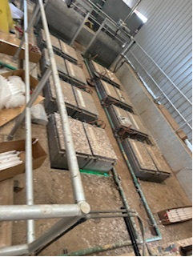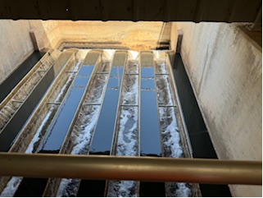
- Area around chemical sanitation
I was not really sure how things flowed in this area but there were large chemical cube like totes with modest sized pumps sitting on the ground and hoses and extension cords running everywhere nearby. I was just thinking how un-reliable the chemical sanitation process looked like but since I did not know what “Proper” looks like I decided to not take picture and listen more about the process.
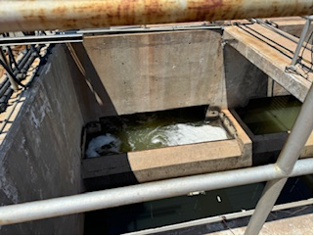

- Effluent pond (holding/detention pond before release to nearby creek
This is the lower elevated area that David remarks is definitely is a flood zone. I am not sure what regulatory flood zone is applicable here (FEMA, City, State etc) but the fact this is prone to flooding after treatment is IMO a critical flaw in this facility design but since water generally likes to flow down-hill it seems to make sense to put this part of the process flow on the lower elevation vs pumping the treating water to a location higher where run-off from nearby operation won’t contaminate the water. I just don’t know enough if this about the impact.
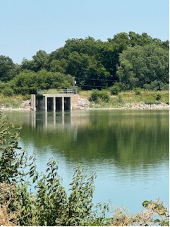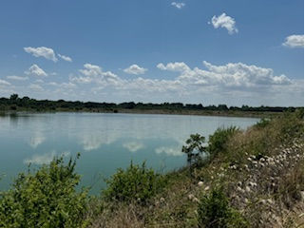

1. PSO pump station from detention pond
This road/trail sits adjacent to the detention pond below a raised earth mound. The area in the distance is a locked PSO facility that has a pump which I believe supplements the pump at Comanche that pulls water to the power facility.
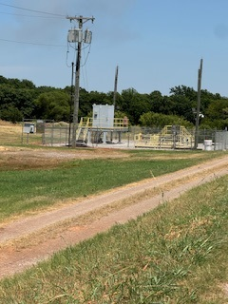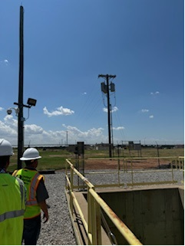
This is the final place where water is pumped. The green growth is apparently normal and fish even like it but there are no fish in this water. I thought a noteworthy remark is there seemed to be an issue with the pump or power to the pump or something which PSO was not aware of. There are fiber optic cables and sensory data for the water level in this well BUT the problem I potentially saw was that the power to the pump was tripped or something and PSO was not ware until we visited the site at that moment. I am not clear on the details but someone made a call if we were pumping and figured out this pump was not going.
